**Heart Disease Prediction Using Amazon Web Services**

Name:Koppanathi.Pujitha

ID:16273485

Mail:pk5pc@mail.umkc.edu

We started using Machine Learning in Amazon Web Services

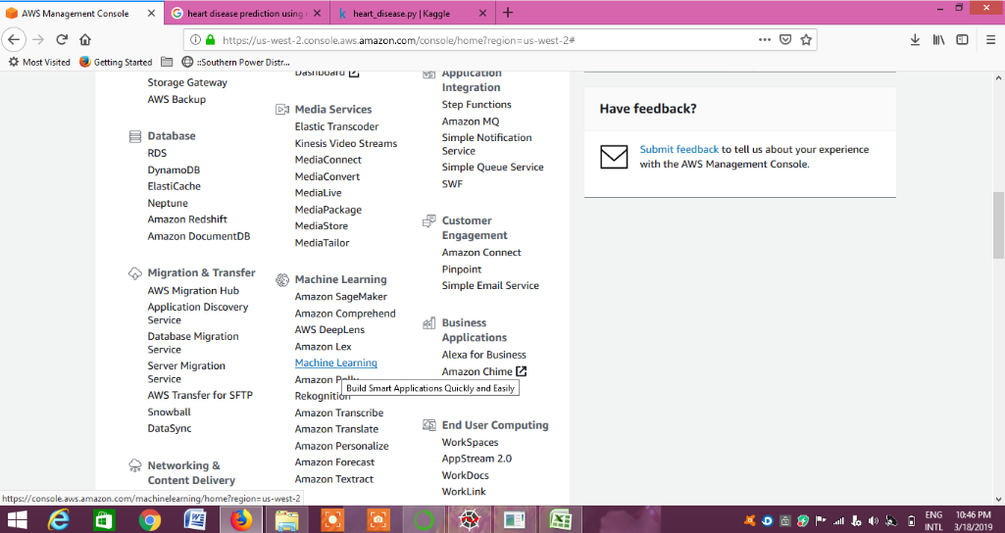

Created a bucket named cloudproject1

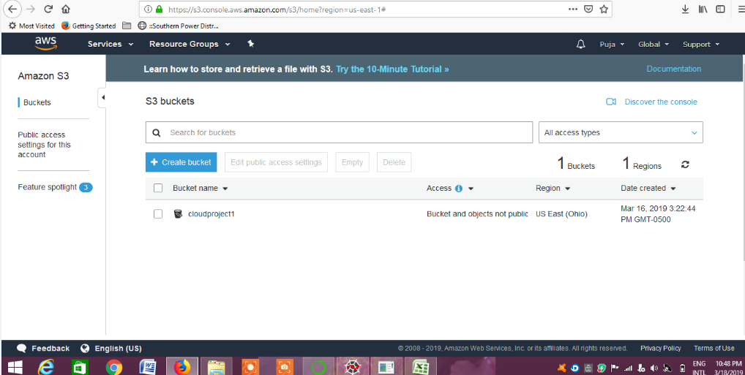

Uploaded the dataset that we require

Here is the link to our dataset: <https://www.kaggle.com/ronitf/heart-disease-uci>

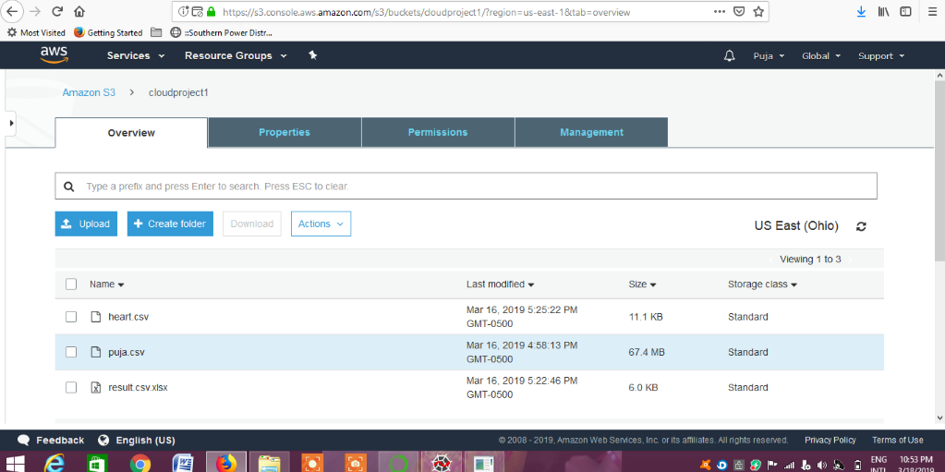

Got the access from the bucket to Machine Learning:

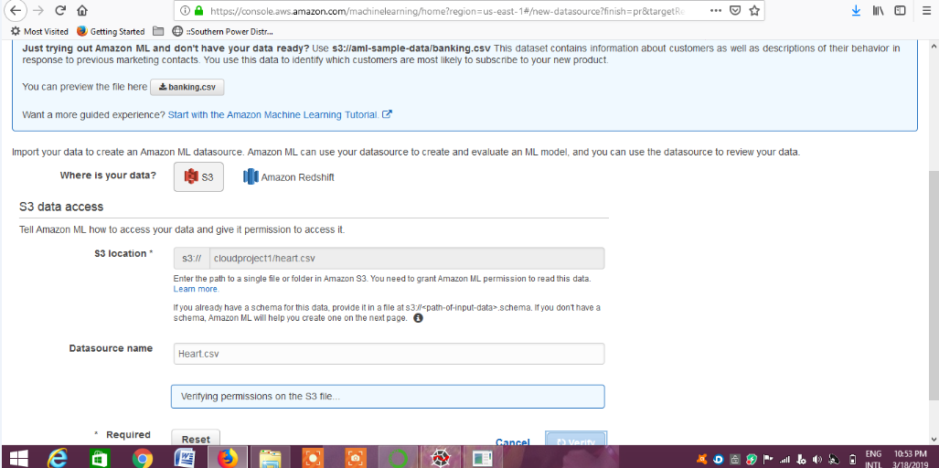

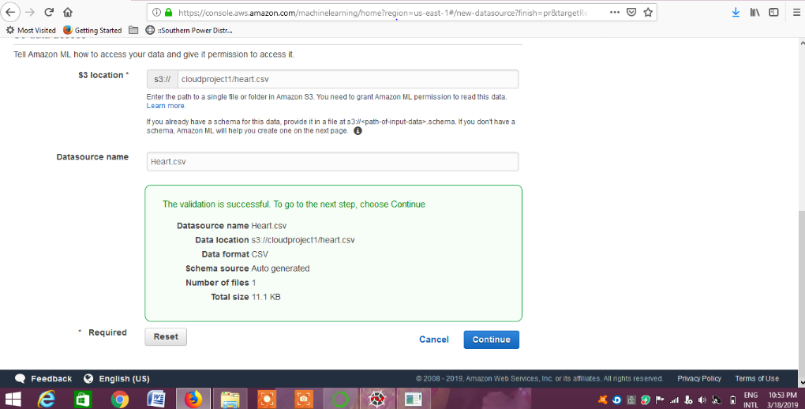

Added the datatype to the columns in the dataset

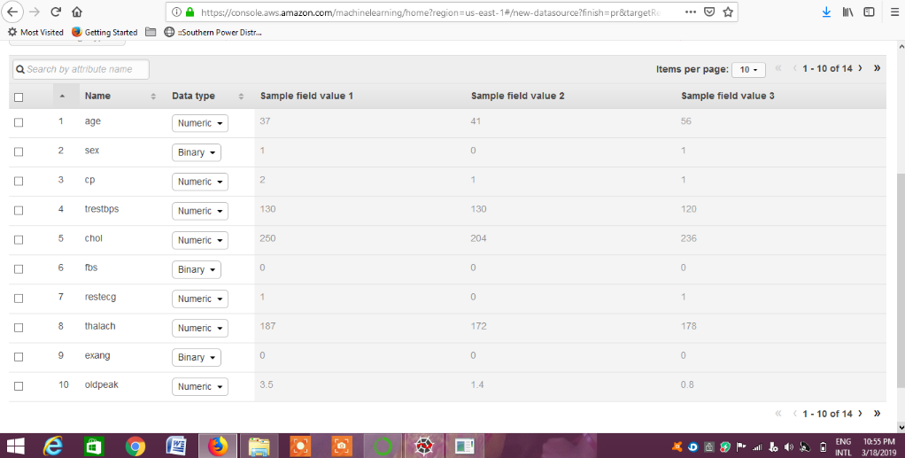

Fixed the target:

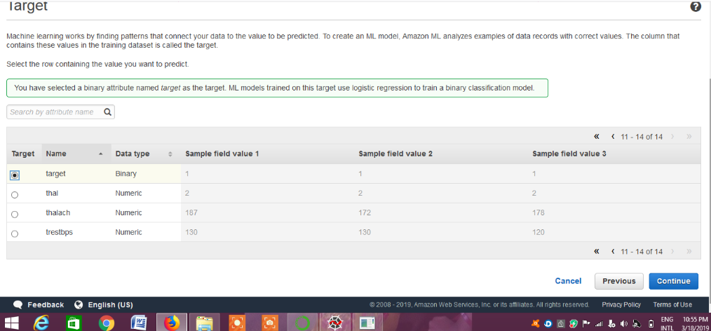

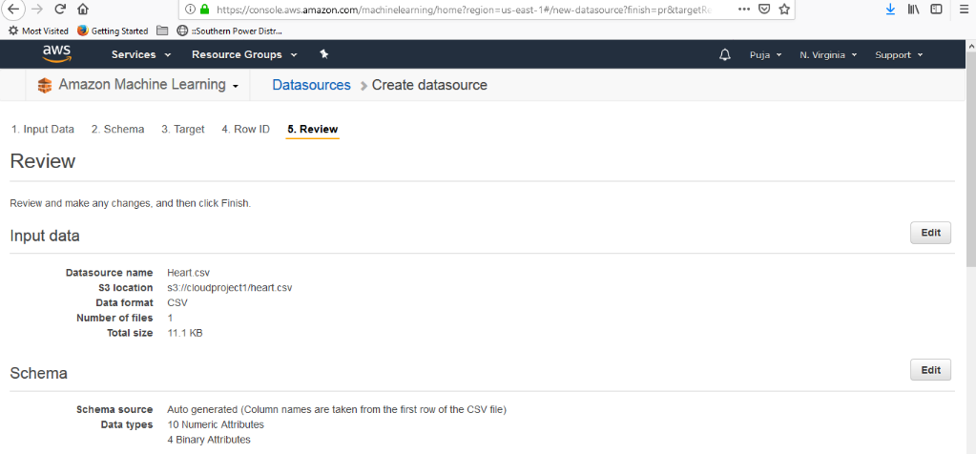

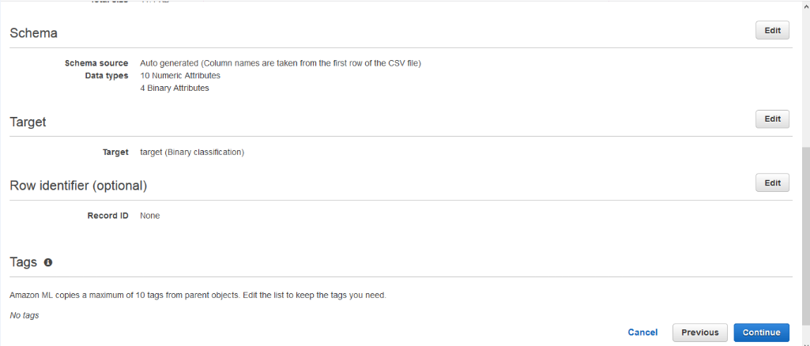

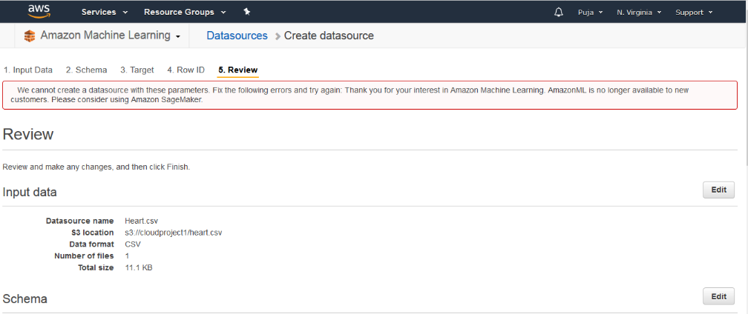

I am not able to access the Machine Learning as it is not accessable for new constumers as it shown

So , we moved on to the Amazon Sagemaker

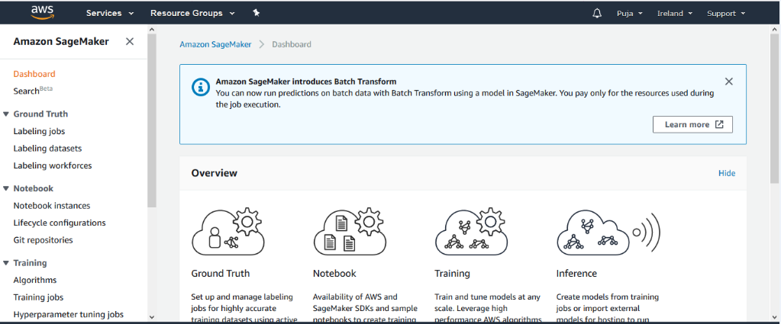

Creating A notebook instance

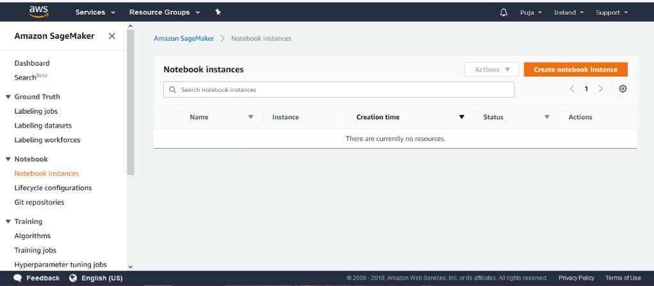

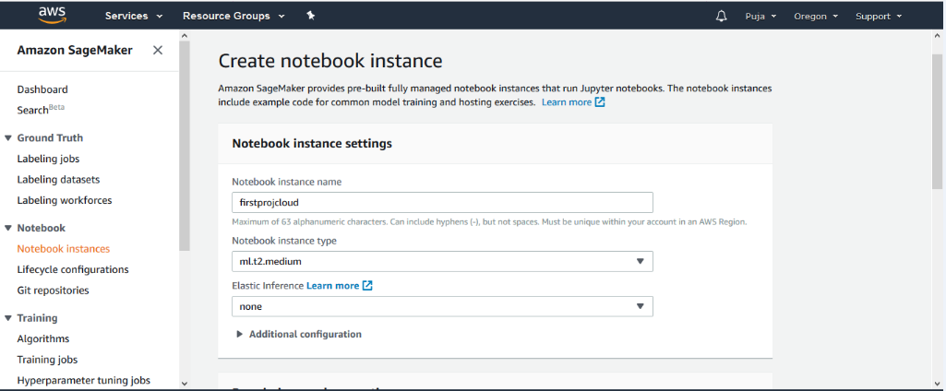

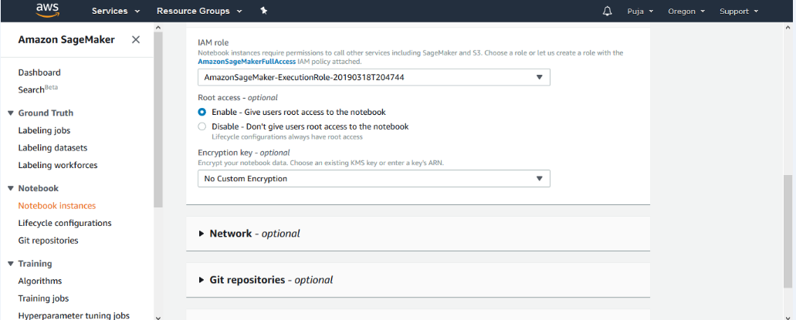

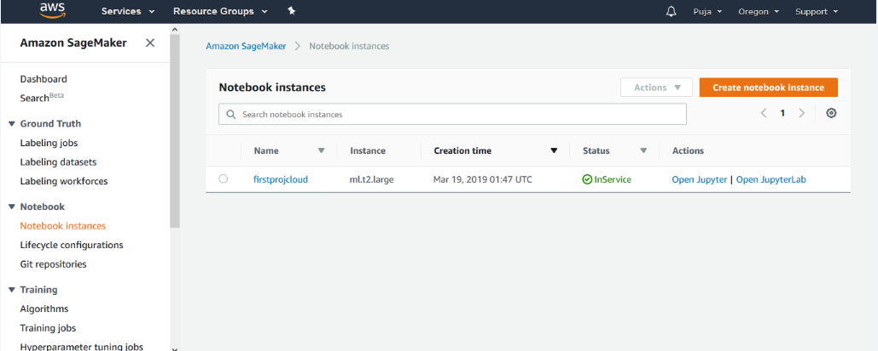

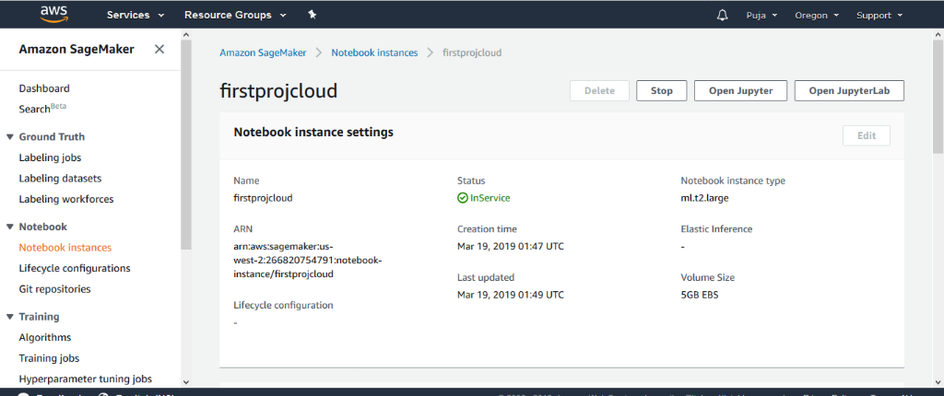

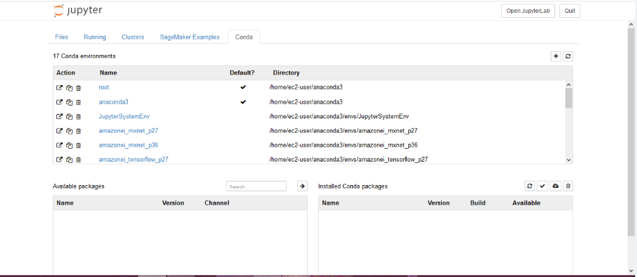

I have implement code for the classification now after.

I got to explore more about SageMaker as it is not my First thought of using in AWS.

Will show you more progress soon.